Booking Date:
Customer Name: |  |  |  |  |  |  | Second Contact:
Company Name:
Address:
Phone Number: |  |  |  |  |  |  | Email:
Date of Event:
Address of Function:
Number of People: |  |  |  |  |  |  | Age Group:
Event Schedule:
 |  |  | Set Up |  | Dinner |  |  | Booth Start |  |  |  | Booth End
Booth Package: |  |  | Silver Gold Platinum DJ Service Add-On
Photo Booth Time: |  |  | 3 Hours 4 Hours 5 Hours
Photo Print Layout:
 |  |  |  |  |  | 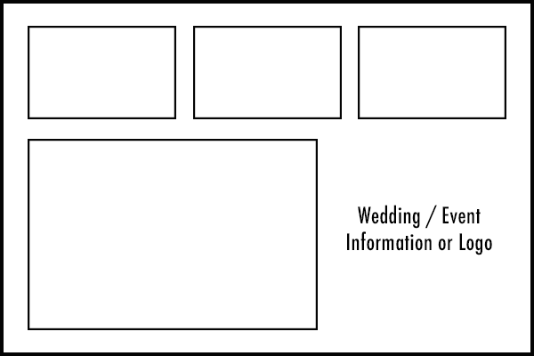 |  |  |  |  | 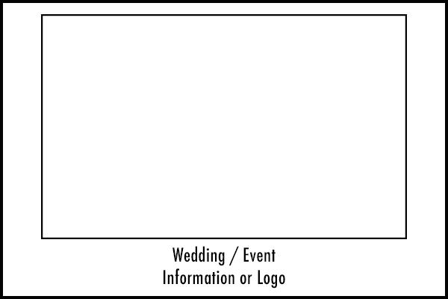
2” x 6” – 3 Images |  |  | 2” x 6” – 4 Images |  |  | 4” x 6” – 4 Images |  |  |  |  | 4” x 6” – 1 Image
Print Tower Colour: |  |  |  |  |  | Photo Tower Colour:
Layout Design & Description:

Deposit Tracking: |  |  |  |  |  |  |  |  |  | Package Price:
Deposit 1: | $ | Date: |  | Visa MC Debit Cash Chq |  |  |  |  |  | Discount:
Deposit 2: | $ | Date: |  | Visa MC Debit Cash Chq |  |  |  |  |  | GST:
Deposit 3: | $ | Date: |  | Visa MC Debit Cash Chq |  |  |  |  |  | Mileage:
Deposit 4: | $ | Date: |  | Visa MC Debit Cash Chq |  |  |  |  |  | Total Price:

Music by Starlite Signature |  | Customer Signature

